|  |  |
| --- | --- |
| EGC_Black | **MATHEMATICS:SPECIALIST 1 & 2**  **SEMESTER 2 2015**  **TEST 5**  **Calculator Free** |

Time Allowed: 25 minutes Total Marks: 23

**1.** [3, 3 marks]

(a) Sketch $y=\sec{\frac{1}{2}x}$ over the domain $-2π≤x≤2π$

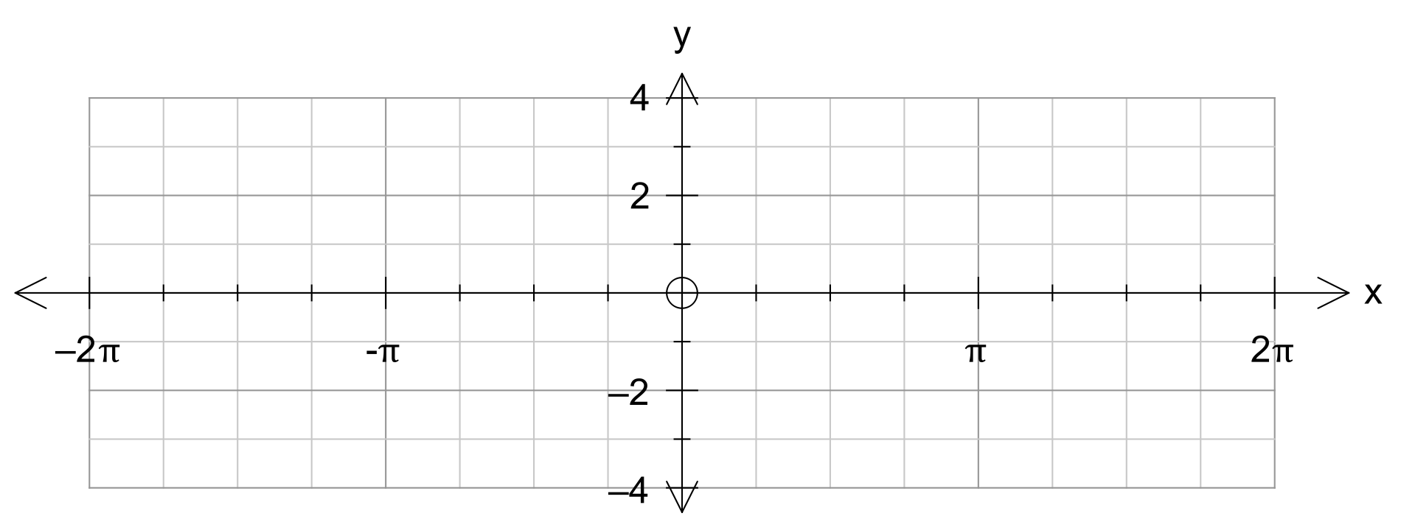

(b) Sketch $y=2\operatorname{cosec}{x}$ over the domain $0≤x≤2π$

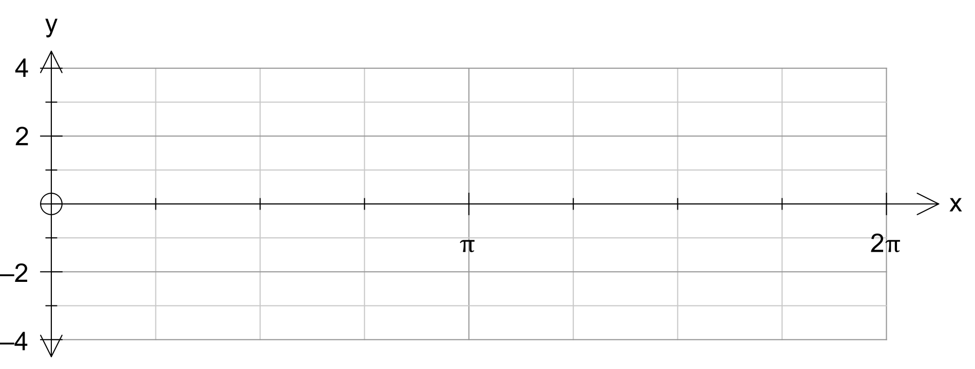

**2.** [4, 4 marks]

Solve the following equations over the given interval

(a) $3\sec^{2} x=4$ for $0≤x≤π$

(b) $6\sin{5x}\cos{4x}=3\sin{9x}-\frac{3\sqrt{2}}{2}$ for $0≤x≤2π$

**3.** [2, 2 marks]

Find all solutions to the following equations for $x$ in degrees

(a) $\sin{x}=0.5$

(b) $\cot{x}=\sqrt{3}$

**4.** [5 marks]

Prove by contradiction: The equation $4x^{2}-y^{2}=1$ has no integer solutions for x and y.

|  |  |
| --- | --- |
| EGC_Black | **MATHEMATICS:SPECIALIST 1 & 2**  **SEMESTER 2 2015**  **TEST 5**  **Calculator Assumed** |

Time Allowed: 40 minutes Total Marks: 35

**5.** [2, 3, 1, 2 marks]

The height of the tide above mean sea level at a certain port has been modelled by the equation

$h\left(t\right)=4\sin{\frac{π(t+1)}{6}}$

where *t* is the number of hours after midnight on a particular day.

(a) Neatly sketch the graph for $h\left(t\right)=4\sin{\frac{π(t+1)}{6}}$ for $0≤t≤24$

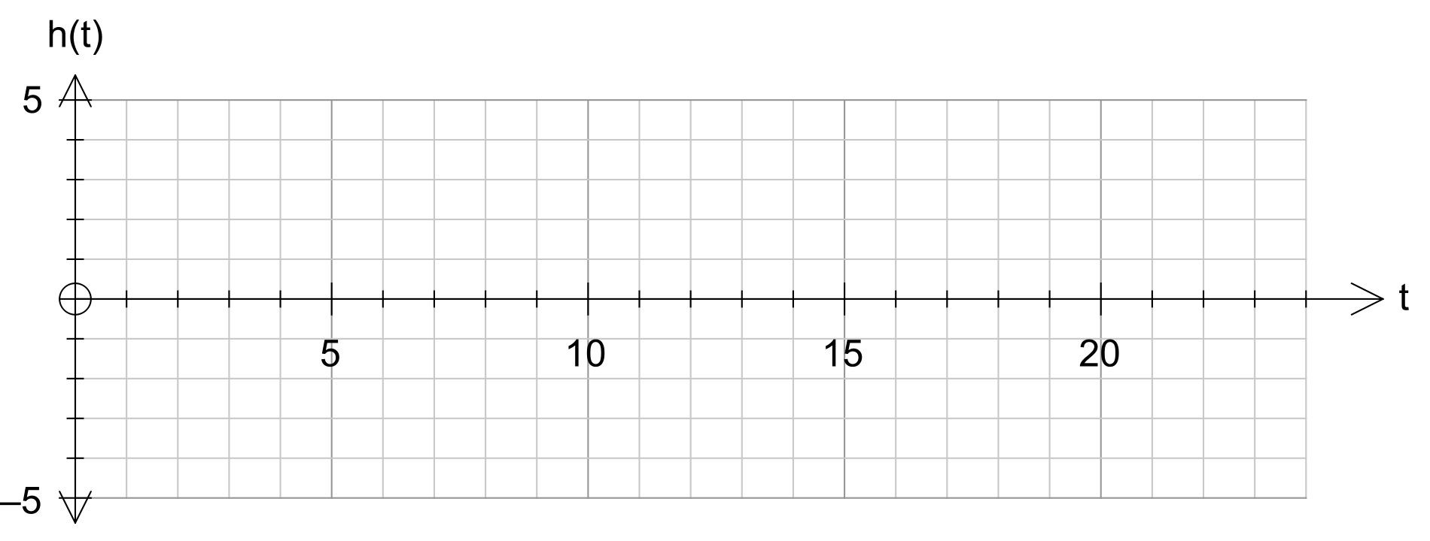

(b) When was the high tide? What is its height above mean sea level at this time?

(c) What was the height of the tide at 8 pm?

(d) A ship can only enter port when there is a depth of 3 metres of water above low tide. Between what times could a ship enter or leave port? Give answers to nearest 5 minutes.

**6.** [2, 5 marks]

(a) Express the product $\cos{45°}\cos{15°}$ as an exact value.

(b) Prove that $\frac{\cos{6θ}\cos{3θ}+\sin{2θ}\sin{θ}}{\cos{5θ}}=\cos{4θ}$

**7.** [4, 4, 3 marks]

(a) Prove that 3 more than the square of an odd number is always divisible by 4.

(b) Consider three consecutive numbers. Prove that the sum of the cube of the smallest number, the square of the middle number, and the largest number will always be a multiple of the middle number.

(c) Express $0.14527527527…$ as a fraction. Show full working.

**8.** [3, 2, 4 marks]

Determine the equation of the following graphs”

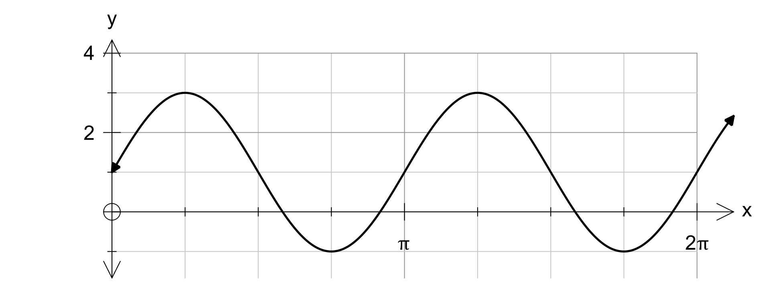(a) y =

(b) y =

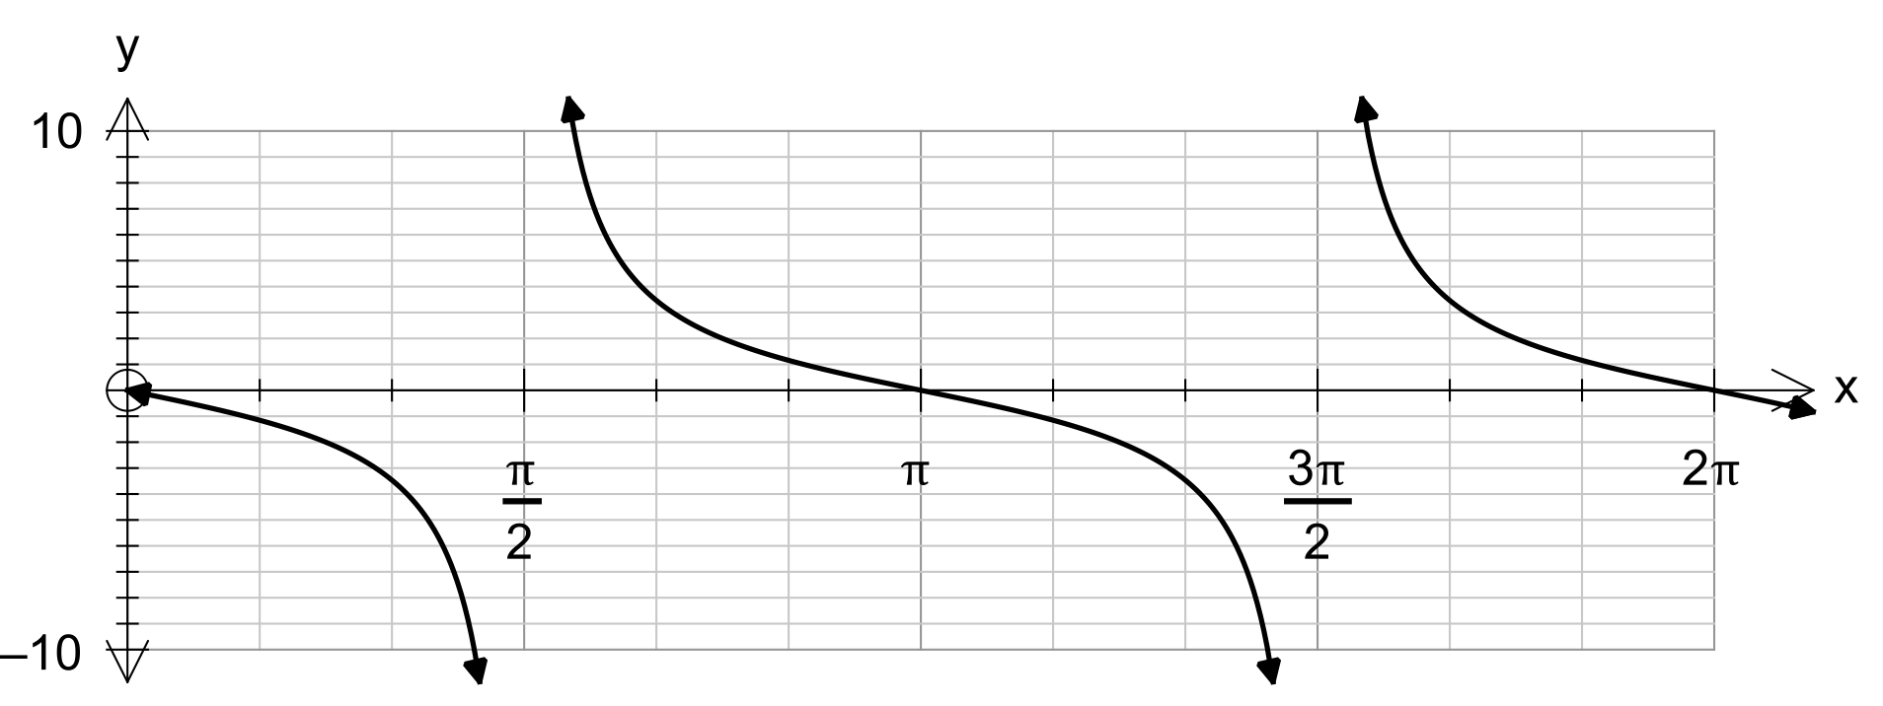

(c) y =

